ABSTRACT

This presentation provides an overview of the evidence on best practice in working with self-neglect

BIOGRAPHY

Suzy Braye, OBE, FAcSS

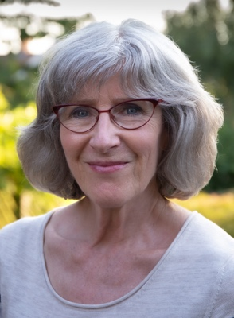

Practising as a consultant and researcher in safeguarding adults, Suzy acts as an independent reviewer in safeguarding adult reviews and provides training and practice development workshops to local authorities, health trusts, ICBs and Safeguarding Adults Boards. She is a qualified social worker with a professional and management background in local authority social services and has also held training, research and management posts in higher education. Her research into self-neglect, conducted for the Department of Health & Social Care and carried out in partnership with Michael Preston-Shoot and David Orr, has been influential on the development of both national and local policy in self-neglect. She is a Fellow of the Academy of Social Sciences and in 2017 received an OBE in recognition of her contribution to the safeguarding adults field. Together with Michael Preston-Shoot and Research in Practice, in 2020 she led the first national analysis of learning from safeguarding adult reviews: https://www.local.gov.uk/publications/analysis-safeguarding-adult-reviews-april-2017-march-2019. The same team are now working on a second national analysis, commissioned by Partners in Care and Health https://www.local.gov.uk/our-support/partners-care-and-health for completion in 2024.

