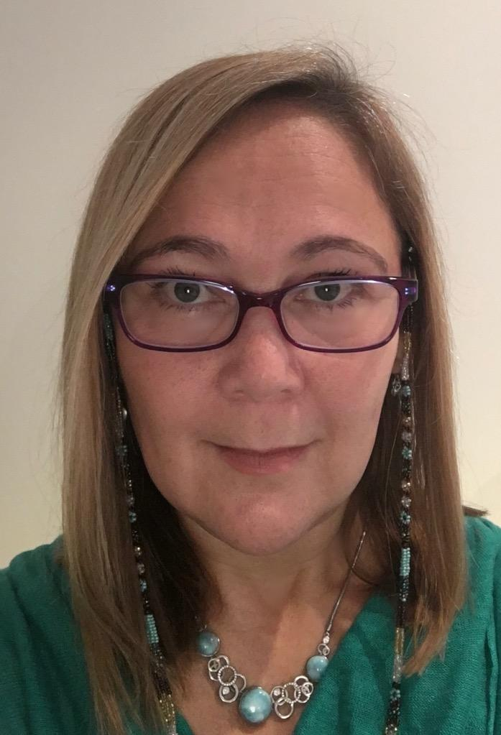Dr Sarah Russell, RGN.
Professional and Practice Development Facilitator (South West), Dementia UK.
Visiting Clinical Reader, University of Surrey (Faculty of Health and Medicine) Visiting Fellow, University of Southampton (Ageing and Dementia) Florence Nightingale Foundation Alumni Non Executive Director End of Life Integrator

Dr Sarah Russell is Admiral Nurse Professional and Practice Development Facilitator at the national charity Dementia UK and has combined being a nurse and family carer for 17 years. Sarah is particularly interested in end of life care as a nurse, educator and researcher. She can often be found on Twitter as @LearnAdmirNurse or @WeEOLC

Abstract
In this session, we will explore some of the experiences of people with dementia, living and dying at the time of Covid-19. What has it meant and what can we learn from it?

