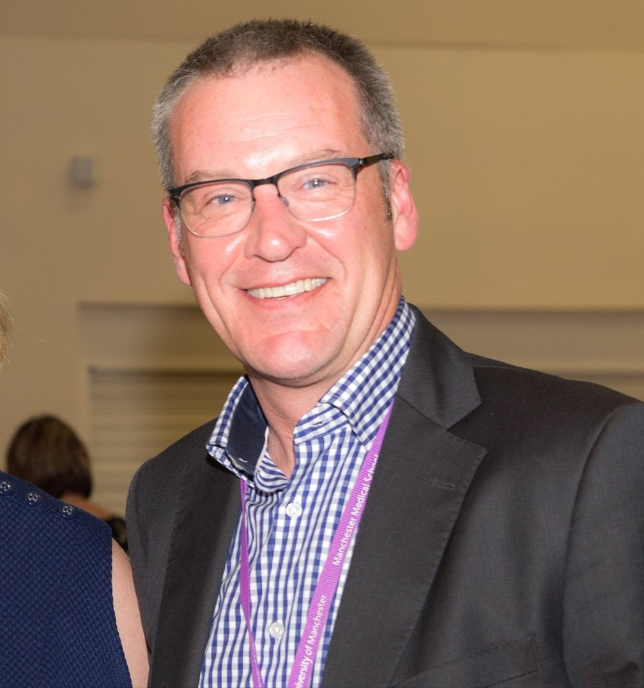Dr Iain Lawrie
Dr Iain Lawrie is Macmillan Consultant in Palliative Medicine at North Manchester General Hospital, UK and Associate Hospital Dean for Communication Skills Teaching / Honorary Clinical Senior Lecturer at Manchester University Foundation NHS Trust / University of Manchester.

Iain started life as a Physiotherapist for a number of years before studying Medicine in Leicester. He entered Palliative Medicine through the General Practice route.

Iain became a Consultant in Palliative Medicine in Manchester in 2008, works in mostly secondary palliative care and has been both Lead Clinician and Director of Medical Education across a large five-site NHS Trust. He has published many peer-reviewed papers, book chapters, on-line learning modules and conference papers. Iain was Vice Presdient and then President of the Association for Palliative Medicine of Great Britain and Ireland between 2017 and 2021, and is currently a Trustee of the RCP (London), a member of RCP (London) Council and other RCP committees and the Editorial Boards of the European Journal of Cancer Care, BMJ Supportive and Palliative Care and Introducing Palliative Care. Iain is also a specialist advisor to several NHS England / Improvement and Royal College work streams.

