Dr Sarah Holmes
Medical Director, Service Transformation, Marie Curie.

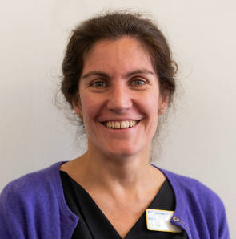
Born in Lancashire and educated in Lancashire and Bristol, Sarah studied medicine in Edinburgh, graduating in 1997. She initially pursued a career in General Practice, before discovering her vocation in Palliative Medicine. Sarah is a Consultant in Palliative Medicine and Medical Director of Marie Curie Hospice Bradford, where she has worked since 2007. In July 2020, Sarah became UK Medical Director for Marie Curie, and combines this role with her ongoing clinical work in the hospice in Bradford. She works with other palliative care consultants and staff within the Bradford and Craven Managed Clinical Network for Palliative Care, which won the BMJ Palliative Care Team of the Year in 2015.

Sarah has an interest in improving palliative care services for young people, including those transitioning from paediatric to adult services, and in developing and improving hospice services for patients with neurological conditions. She is passionate about ensuring better end of life care for all, especially for marginalised groups including the homeless, and in delivering truly person centred care as part of a place based approach.

