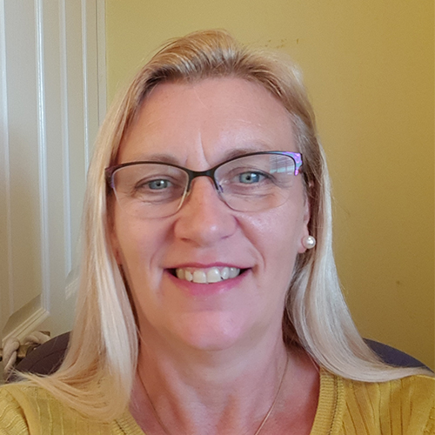
Jacqui Fletcher OBE is currently Senior Nurse Advisor – Stop the Pressure Programme, an Independent Wound Care Consultant, and Editor of Wounds UK journal.
Prior to this Jacqui was the Clinical Strategy Director at the Welsh Wound Innovation Centre and had an honorary clinical contract at Cardiff and Vale UHB. Jacqui was an Honorary Fellow of the National Institute for Health and Care Excellence (NICE) from 2011 - 2014. She has worked for Midlands and East Strategic Health Authority as Harm Free Care Lead, focussing on the ambition to eliminate all avoidable category 2,3 and 4 pressure ulcers. She has also worked as a Principal Lecturer, University of Hertfordshire.
She is a Patron of the Lindsey Leg Club, and a member of the Editorial Advisory Board for International Wound Journal, the Journal of Wound Care and Wounds UK journal. She served as an Executive of the European Pressure Ulcer Advisory Panel from its inception in 1996 until 2010 and was instrumental in developing the 2009 guidelines serving as a lead for a working group.
She has published widely and speaks at both national and international conferences.

Qualifications
OBE – Queen’s Birthday Honours List 2020
RN, MSc, PGC (Ed) BSc (Hons) FHEA
Registered Nurse
MSc Wound Healing and Tissue Repair
PG Cert – Education
BSc (Hons) Healthcare Studies
Fellow of Higher Education Academy

