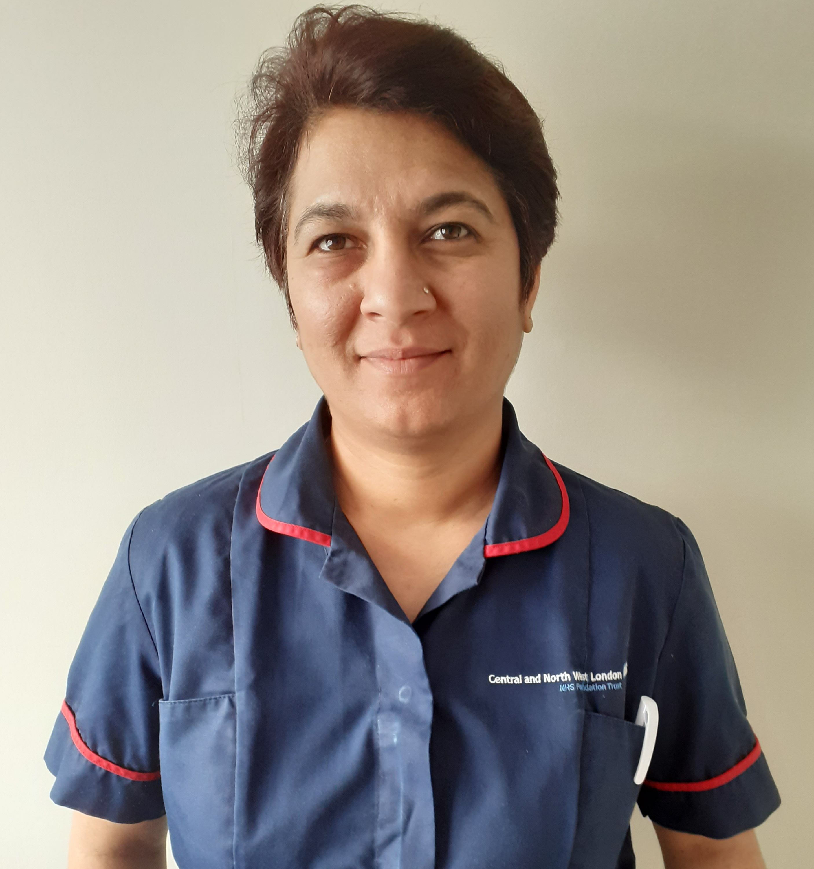Luxmi Dhoonmoon
My name is Luxmi Dhoonmoon, Nurse Consultant Tissue Viability working for Central North West London NHS trust.
Completed my BSC (Tissue Viability Pathway) in 2010 and MSc Advanced Practice in 2013, from St Georges university of London. Currently enrolled on PhD in Nursing studies with University of Nottingham.
Passionate about wound care and have a passion for all types of wounds. Introduced the Stop the Pressure campaign across CNWL NHS trust to reduce harm in our care homes and reduce our safeguarding concerns in regards to PU. Also lead a team of Tissue Viability Nurses and Nursing Assistants to deliver a seamless service across the community both for ambulant and housebound patients and also in care homes and mental health settings.
Won the JWC award for Best Clinical research in 2015 for making a difference in patient with chronic wound while using topical Oxygen therapy. Contributed to several case studies, best practice statement and research to enhance clinical evidence forming the future of practice.
Published several clinical evaluations on patient’s care and improvement and recently authored an article in Independent Nurse on Long Covid and self care.
My aim is to currently develop my clinical research further to improve public health and lower limb care in the community.

