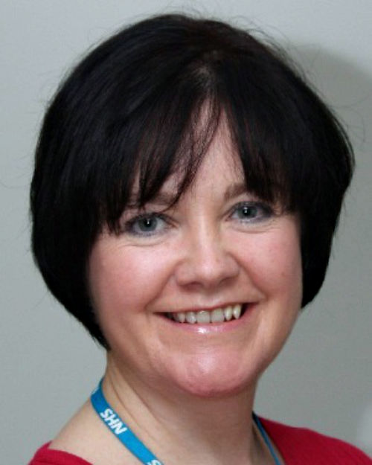Dr Paula Powell
Dr Powell is the medical director and Caldicott Guardian of Willowbrook Hospice in Merseyside. The hospice is a 12-bed in-patient unit for people with life-limiting conditions of all causes. She has been a clinician for 30 years, starting as a GP before finding her very rewarding role in palliative care.

