Alan Nobbs – Biography
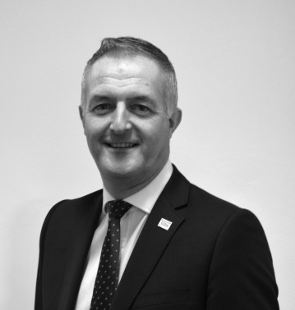
Alan Nobbs MA
Head of Design and Development
NHS Leadership Academy

Alan joined the NHS via a clinical route, commencing his registered general nurse training in 1984 and is currently the Head of Programme Design and Practice at the NHS Leadership Academy – having first joined the team in April 2013.
Following working in a variety of acute healthcare clinical practice roles, spanning a sixteen-year period, Alan moved into an acute trust strategic management role with organisational responsibility for the delivery of the National Service Framework for Coronary Heart Disease in 2000. Although part of a wider career development plan to progress to executive nursing director-level roles, the move prompted a change in career direction as he had the opportunity, during this period, to work closely with the Modernisation Agency where he developed a keen interest in the fields of innovation, improvement and leadership for change.
His subsequent positions include working at both a regional and national level in a number of senior service innovation and improvement leadership roles – leading the establishment of a Managed Cardiovascular Clinical Network across North East Yorkshire and Northern Lincolnshire before moving to the NHS Institute for Innovation and Improvement in 2011 where he worked as an Associate within the Thought Leadership Team, exploring social movement thinking and community organising principles and their potential role within the NHS context.
In his current role, Alan leads a broad portfolio of work but, most notably, leads on the quality assurance of design, delivery and leadership development practice for the Academy as a whole.
Alan has practice interests in the fields of cultural competence and the deeper exploration of the implications of equality, diversity and inclusion – helping to inform his practice in the design and delivery of impactful leadership interventions that meet the need to move towards more inclusive, compassionate leadership / organisational cultures within health care.
He holds and MA in Management Learning and Leadership.

You can follow Alan on twitter @Alannobbs

