Professor Mayur Lakhani
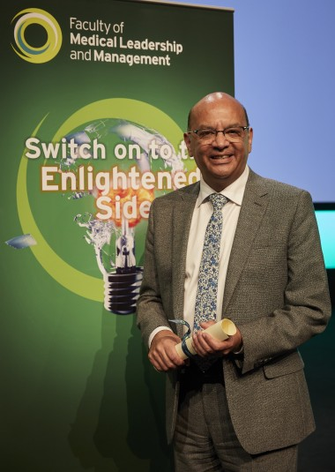Professor Mayur Lakhani CBE FRCP FRCGP SFFMLM RCPathME is a practising GP and experienced clinical leader in the NHS in England. For two years running, in 2006 and 2007, he has been in the Health Services Journal (HSJ) Top 50 most influential people. He was Chairman of the Royal College of General Practitioners from 2004 to 2007. He was the youngest elected Chairman at the age of 43. He is the principal author of the landmark document, The future direction of general practice: a roadmap where he first advocated the idea of federations, the forerunners of primary care networks. At the request of the then Secretary of State for Health, The Rt Hon Alan Johnson MP, he chaired a national enquiry into access to GP services by BAME patients which led to the publication of a report, No Patient Left Behind in 2008.

He was Chair of the National Council for Palliative Care from 2008-2015 where he championed the cause of high-quality care at the end of life for all. In 2017 was elected President of the RCGP, one of only ten GPs to be both Chair and President of the UK’s largest medical royal college. He is now the Chair of the Faculty of Medical Leadership and Management (FMLM). He was awarded the CBE in the Queen’s Birthday Honours list in 2007. He is currently a Chair of a CCG In Leicestershire, and a member of the clinical executive group of the STP/ICS and led the work on principles for recovery and reset following Covid-19 in Leicestershire. He was a senior clinician on the national covid clinical assessment service (CCAS) and has recently completed training to be a Medical Examiner (RCPathME)

