Dr Andrew Stanners
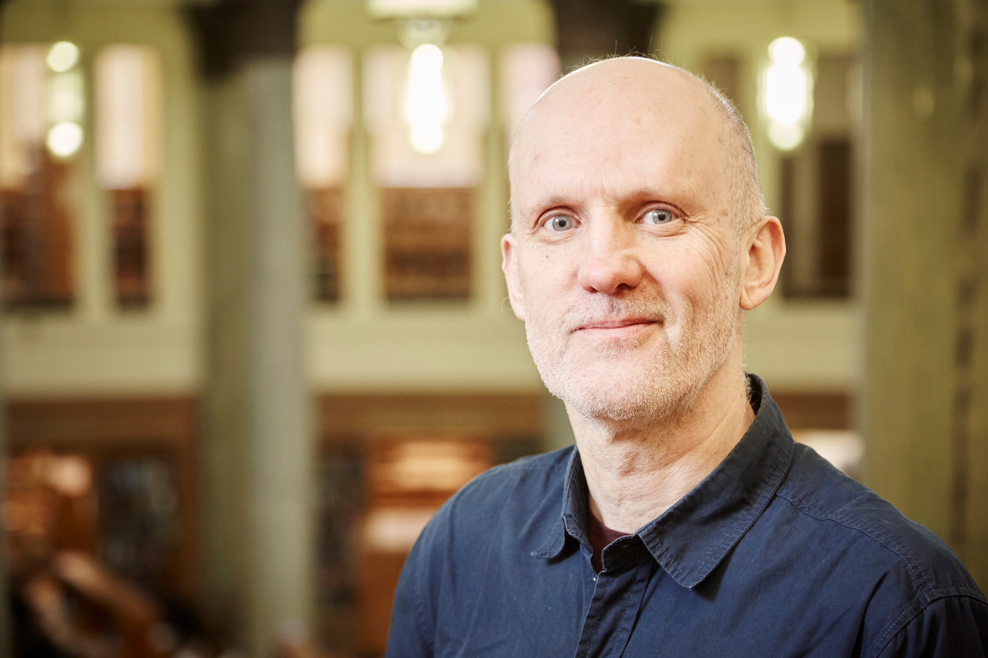Chair, Clinical Ethics Committee
Mid Yorkshire Hospitals NHS Trust
and Trustee for UK Clinical Ethics Network
Andrew is a Consultant Geriatrician at Mid Yorkshire Hospitals NHS Trust where he also chairs the Clinical Ethics Committee. He trained in Healthcare Ethics at the University of Leeds where he teaches medical students and students on the BA/MA in Healthcare Ethics. He is a trustee for the UK Clinical Ethics Network.

