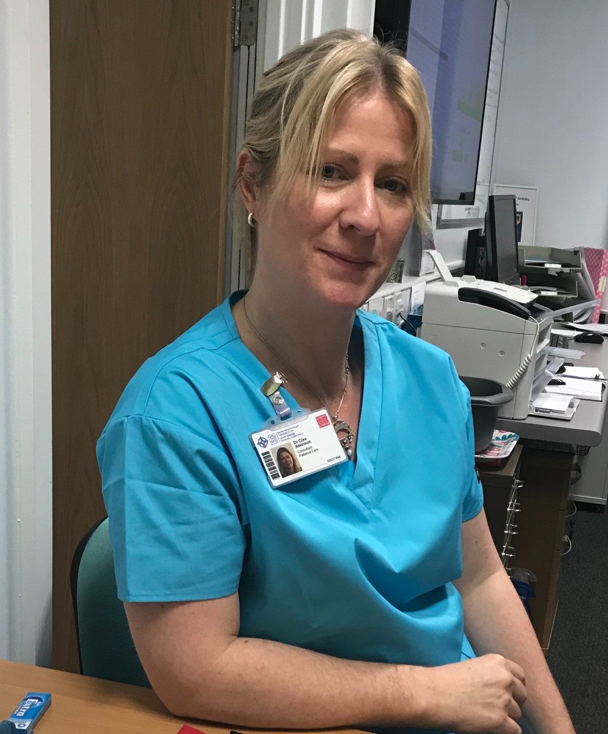Dr Clea Atkinson
Dr Clea Atkinson qualified in 1995 from Southampton University. After being Medical Director at St. Ann’s Hospice, Gwent for almost 10 years she became Palliative and Supportive Care Consultant in University Hospital of Wales, Cardiff, UK in 2015. She is also Honorary Senior Lecturer for Cardiff University and a holds a Bevan Commission Fellowship. She has a special interest in development of Supportive Care pathways for advanced non-malignant conditions and in particular provision of Palliative Care in Advanced Heart Failure work for which she was finalist in the NHS Wales awards and winner in the MediWales award for innovation within the NHS in 2019.

