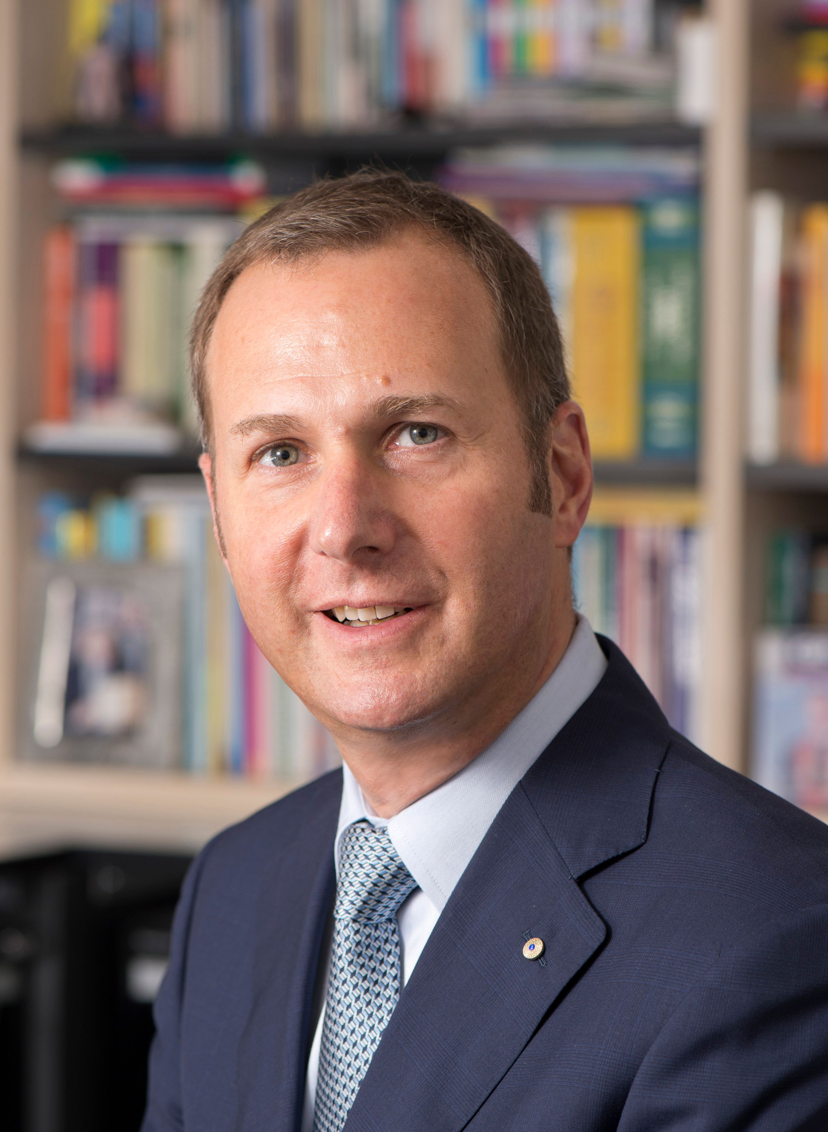Professor Michael Kidd
Professor Michael Kidd AM is Deputy Chief Medical Officer and Principal Medical Advisor with the Australian Government Department of Health, where he is leading Australia’s national primary care response to the COVID-19 pandemic. He also has appointment as the foundation Professor of Primary Care Reform at The Australian National University. He is a general practitioner, a past president of the Royal Australian College of General Practitioners, a past president of the World Organization of Family Doctors (WONCA), and a past Dean of the Faculty of Medicine, Nursing and Health Sciences at Flinders University. He has a long track record in digital health research, advocacy and governance, with a particular focus on electronic medical record and telehealth innovations in general practice. A former director of Telstra Health (Australia’s largest digital health company), he is the current chair of the Australian Alliance for Artificial Intelligence in Healthcare. Prior to returning to Australia to join the Department of Health, he was Director of the World Health Organization Collaborating Centre on Family Medicine and Primary Care, Senior Innovation Fellow with the Institute for Health System Solutions and Innovative Care, and Professor and Chair of the Department of Family and Community Medicine at the University of Toronto in Canada.

