Kirsty Fishburn BSc (hons), INP, MSc, RMN, SFHEA – Biography
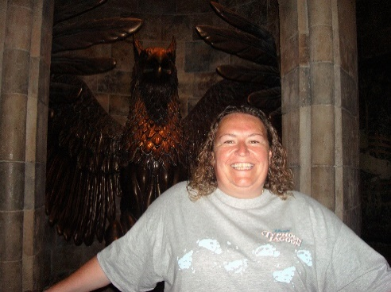
I became a mental health nurse when I realised I couldn’t be in the A-Team. Therefore, I have been and loved being a mental health nurse for 20 years and during that time I have worked mainly in secure forensic hospitals run by private providers. I have undertaken many courses course from CBT to Mentorship and then onto Prescribing and up to my Master’s degree. I am now undertaking my PhD in Personality Disorder.
My clinical practice career took me from staff nurse to hospital director, then in January 2015 I left practice to go into the world of academia. I was always on a course at one university or another, so I decided to just go work there.... I am very lucky at the University of Hull. Also being new to the world of academia and research I am very lucky to have been published quite a few times, in mental health prescribing and personality disorder…. Exciting times.
I am the programme Director for the mental health BSc at the university. We work very well as a team and looking at how we can best equip the student nurses with the skills they will need to become excellent qualified nurses.
I qualified as a non-medical prescriber in 2007 and was an active prescriber in clinical practice, I found it a challenging and rewarding role, as I think it is very difficult to understand the accountability and responsibility we have in our role unless you actually can and do write a prescription.
When I left practice I was very lucky to take on the module leader for the nurse’s independent and supplementary prescribing course at the university, a course of which I am very proud to be part of. This is a very exciting role with developing course content, assessments and linking in with other HEI’s, service providers and servicer users to develop robust courses and keeping them relevant and reflective of current prescribing practice.
An ever changing world in mental health, that keep most of us excited and apprehensive at the best of times, but it is my passion.
When I have free time, I like to relax with my husband and a scary horror movie or go out to the movies with the kids.

Thank you
Kirsty

