Dr Mehtab Ghazi Rahman MBBS BSc(Hons.) MRSB MRCPsych
Consultant Psychiatrist, Nile Ward Psychiatric Intensive Care Unit
St Charles Hospital, Exmoor Street, London W10 6DZ
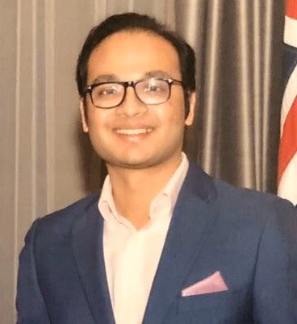Dr Mehtab Ghazi Rahman is a Consultant Psychiatrist and the Responsible Clinician for Nile Ward Psychiatric Intensive Care Unit, St Charles Hospital. He qualified from St Bartholomew's and the Royal London Medical School and completed his psychiatric training under the St Mary's and Charing Cross training schemes in London.
Dr Rahman joined CNWL in April 2020 as a Consultant Psychiatrist. In addition to his Consultant role, he is the Trustwide Physical Health lead in Mental health Services, CNWL Flu Group Medical Lead, Physical Health Inpatient Lead at St Charles Hospital and the LNC representative for Kensington & Chelsea. He is a Board Member for CPDO at the Royal College of Psychiatrists of the United Kingdom and works closely with various charitable organisations in developing countries. Dr Rahman has received awards for his quality improvement work in improving physical health in mental health settings and reducing violence in psychiatric intensive care settings.

