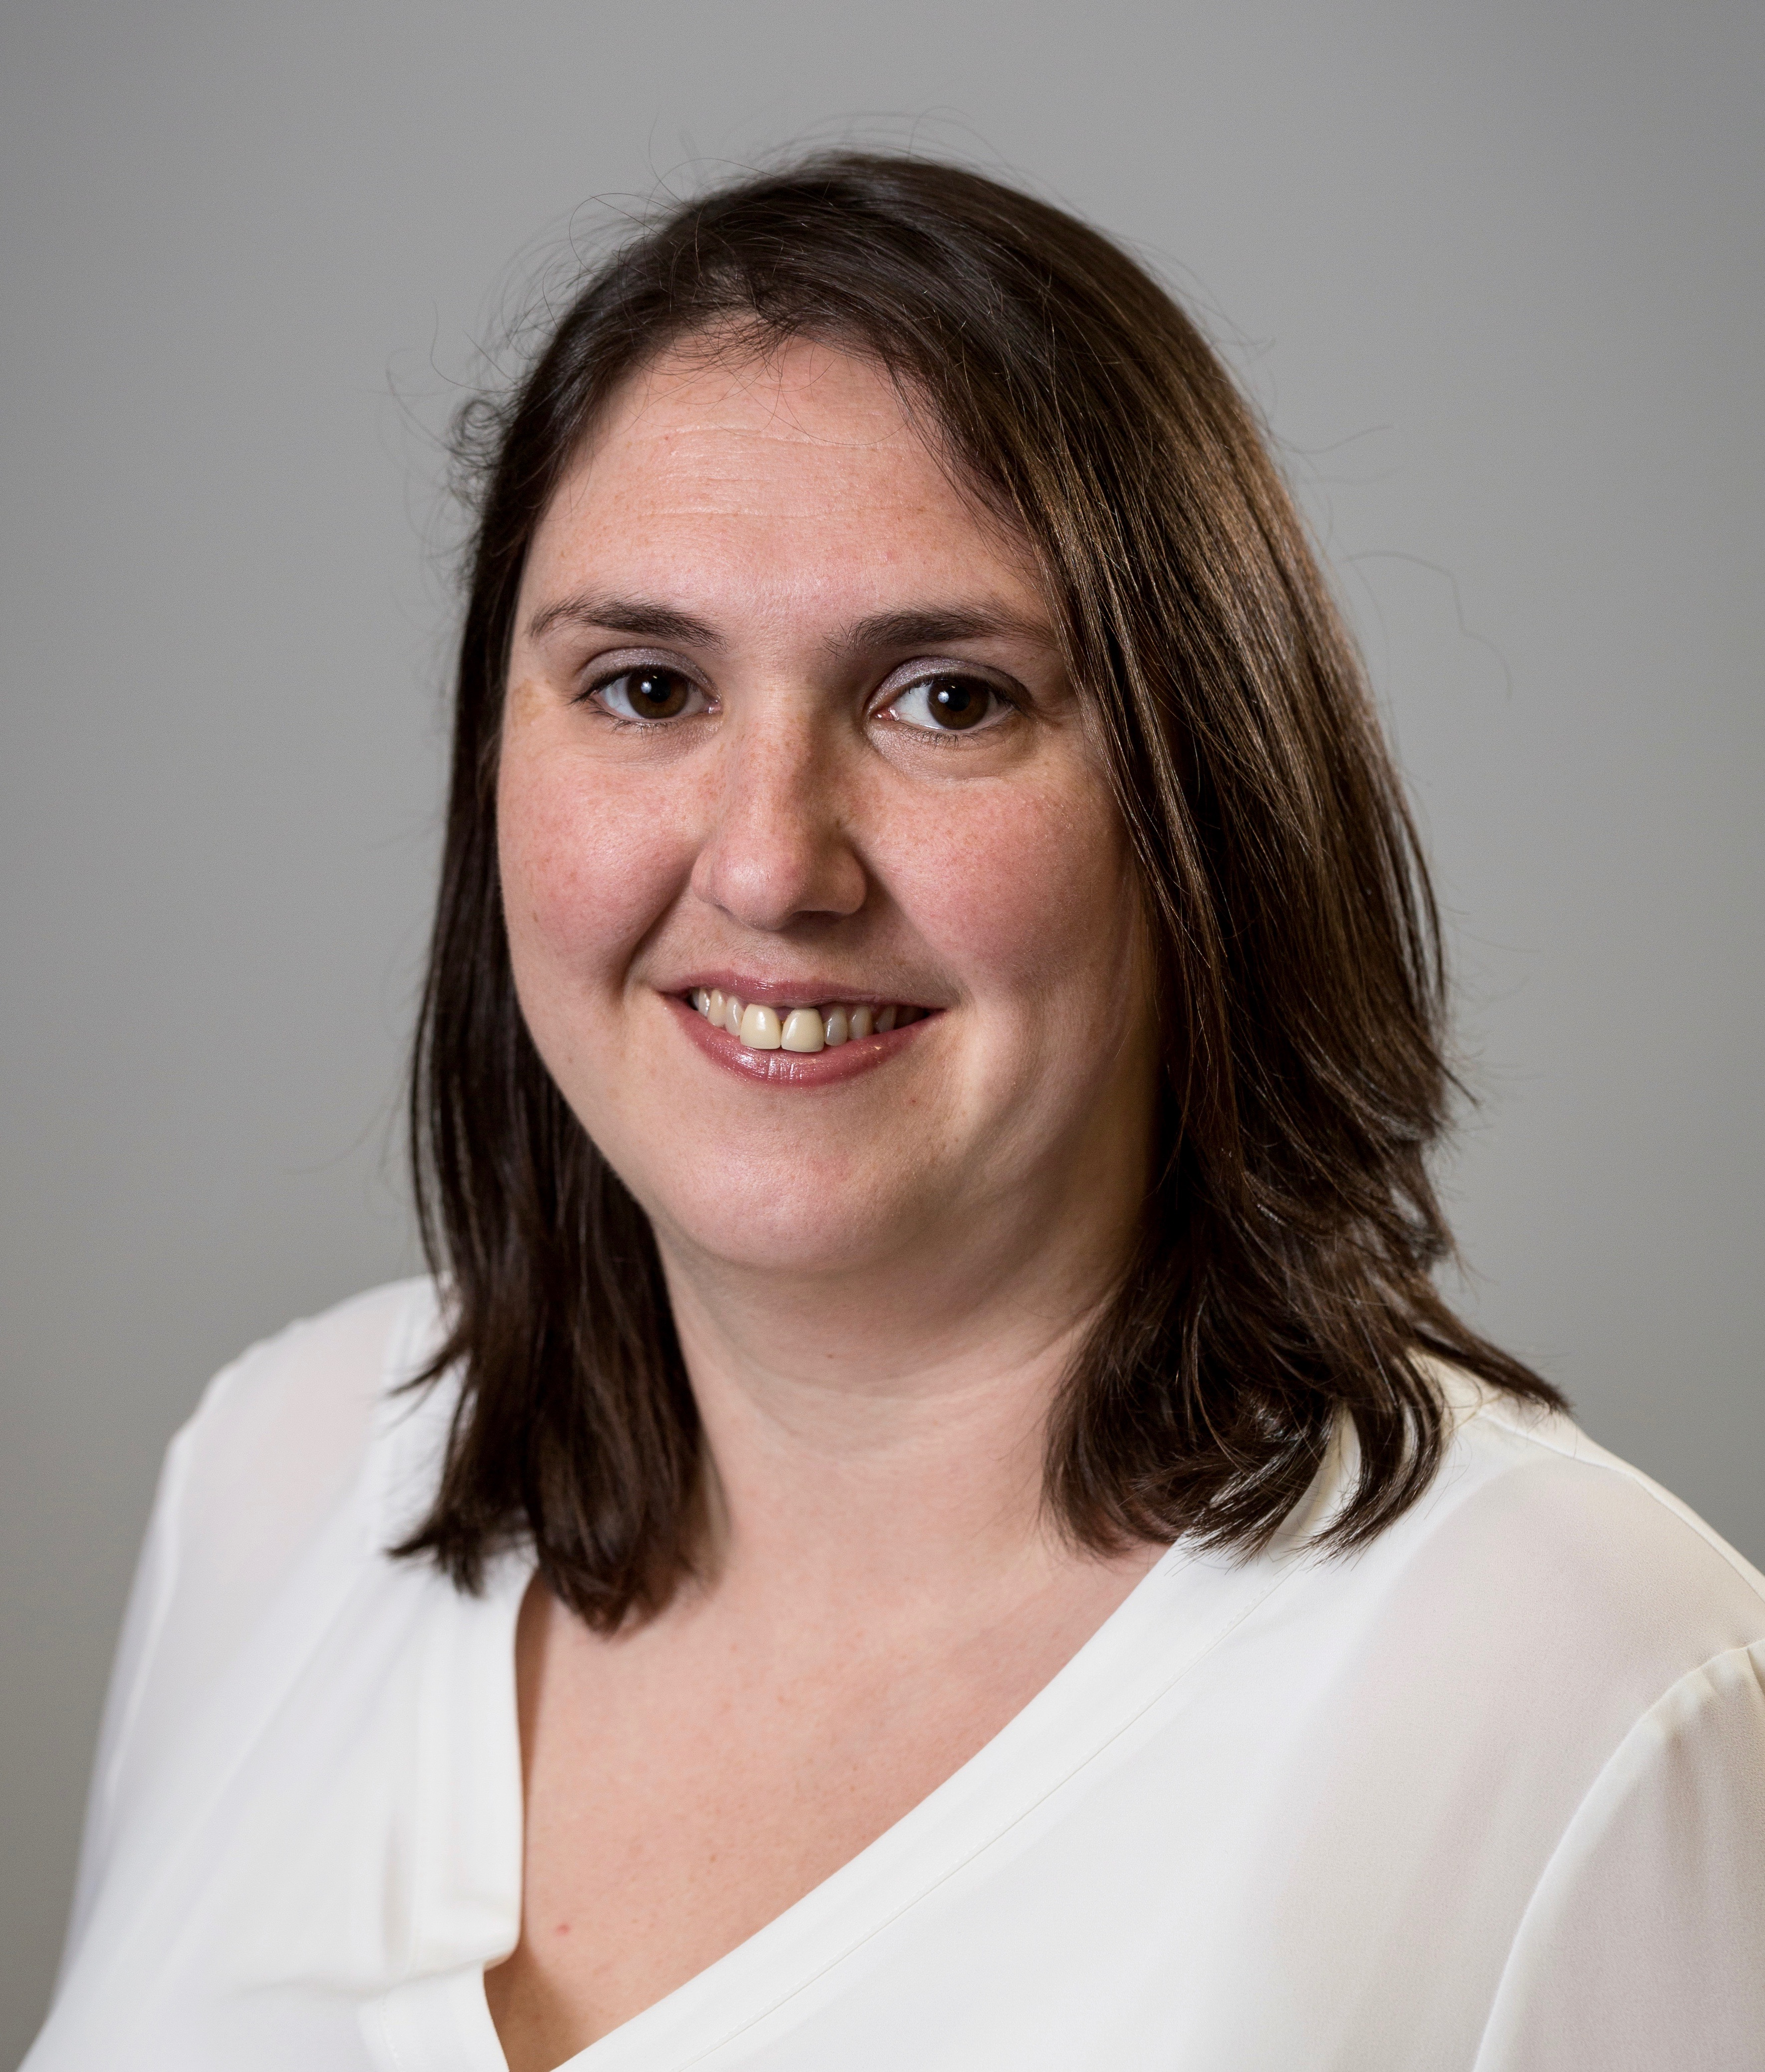Kate Straughton
President
The Faculty of Physician Associates
Kate is a qualified PA, graduating from the University of Birmingham in 2009 and completing her MsC in 2017 from the University of Worcester. She has over ten years’ experience including working in acute medicine and neurosurgery. She has been working in PA education since 2014, with a focus on work-based learning and clinical placements. Kate is currently the placement lead for the University of Birmingham PA course, and also oversees the MSc ‘top up’ for PAs who wish to carry out some further research.

