Dr Nick Scriven
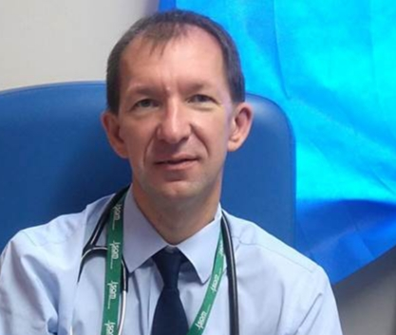Dr Nick Scriven is an Acute Medicine consultant working for the Calderdale and Huddersfield FT and has been in post in Halifax for nearly 20 years having trained in the East midlands. He is currently the Immediate Past President of the Society for Acute Medicine having held the presidency for a two year term completing in Oct 2019 and has so far been on the SAM council for 8 years. His work interests include Same Day Emergency Care (he is on the program board for the NHSE/I SDEC group) and NIV fo respiratory failure. He has also recently been appointed as assistant medical examiner for CHFT.

