Immediate Past President of the Royal College of Physicians of Edinburgh, Derek’s terms of office ran from March 2014 to February 2020. He was also the Director of the NIHR CLAHRC for Northwest London for over 11years. Derek was appointed as the first Professor of Acute Internal Medicine in the UK at Imperial College London and was the inaugural President of the Society for Acute Medicine. In early 2017 he was appointed as an NIHR Senior Investigator and later that year he was awarded an OBE for his services to Unscheduled Care and Quality Improvement.
Professor Derek Bell OBE
BSc(Hons) MBChB•MRCP•MD•FSAM
FRCPE•FRCPSG•FRCPL•FACP

Imperial College London
Chelsea and Westminster Campus
369 Fulham Road, London
SW10 9NH

E: d.bell@imperial.ac.uk

Graduating from Edinburgh University in 1980, he initially specialised in Respiratory and General Medicine, with an interest in Intensive Care, before subsequently developing his role in Acute Medicine. Prior to moving to Imperial College he was Associate Medical Director in Edinburgh. He has lead and designed several national programmes of work including two large national change programmes including the Emergency Services Collaborative with the Modernisation Agency.

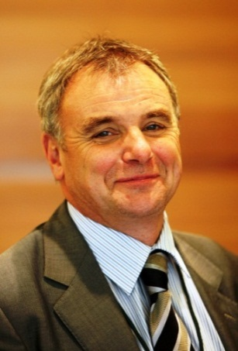
His academic research interests relate to quality and organisation of care, particularly acute medical care, and the methods of delivery of care. He is particularly interested in patient flow and quality of care. As part of this work the team at the Centre for Health Care Improvement and research have supported work in Australia, Ireland and throughout the UK. Clinical interests include illness severity assessment, pulmonary embolism and pneumonia. He teaches on a number of Post-graduate and undergraduate programmes.

Derek has published in excess of 200 peer reviewed papers and has led several policy document initiatives including the development of successful National Early Warning Score to support standardisation of care across the UK. Total research grant income over the last eight years exceeds £22 million. He also Chairs two small medical research charities.

