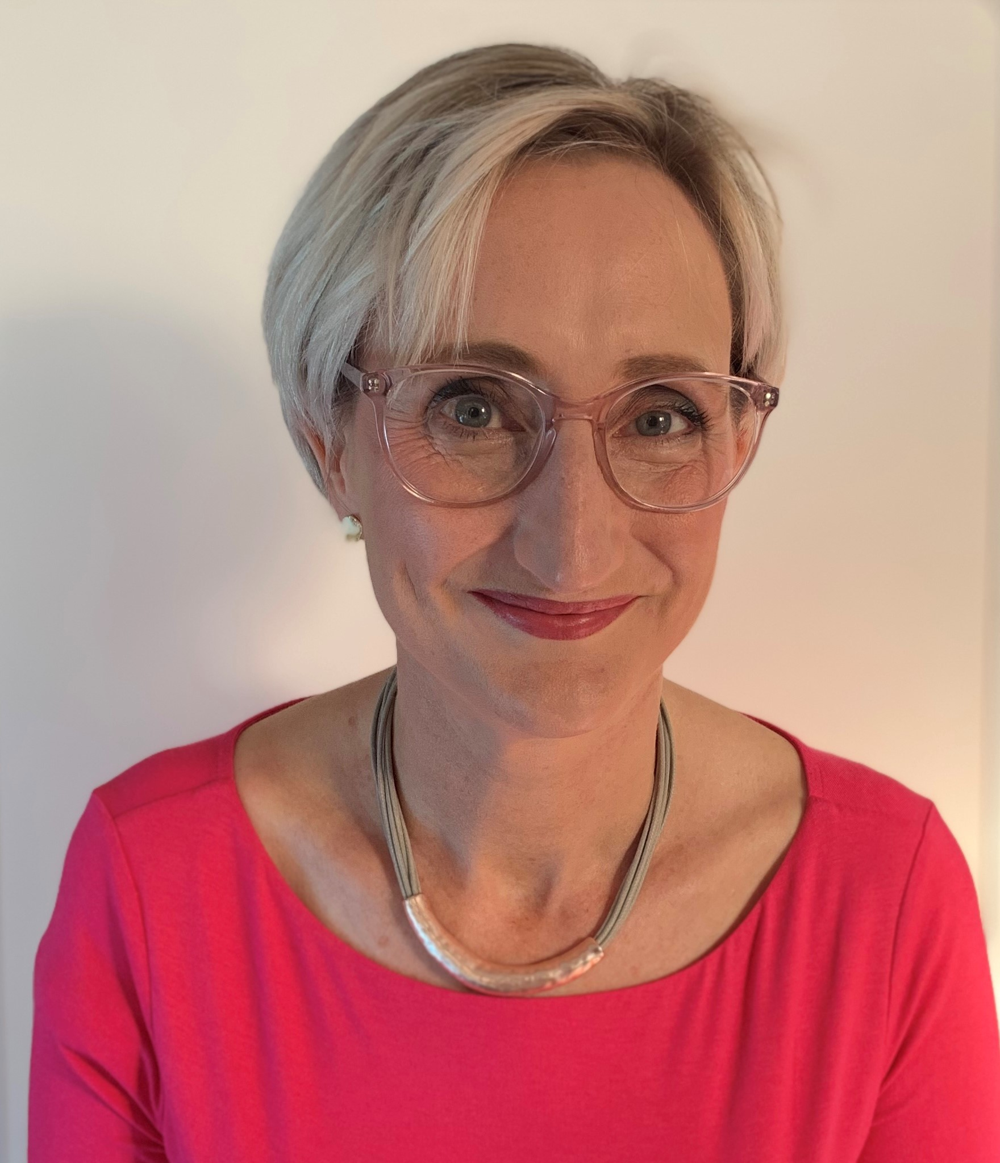Biography
Emma has been the medical director at Glan Clwyd Hospital (part of the largest health board in Wales) since 2015, and will shortly be taking up a new role as the associate medical director for professional development across the whole health board. She has a part-time role as a consultant anaesthetist. Emma has ten years of experience managing and supporting doctors in difficulty. She is also an experienced appraiser and case manager.
Emma is a fellow of the Faculty of Medical Leaders and Managers and is studying for an executive MSc in medical leadership at the City of London University.

ejhosking@gmail.com emmajane.hosking@wales.nhs.uk
Phone: 07970491472
Twitter: @DrEmmaHosking

