Abstract – September 2021 Deborah Robertson

Ensuring Competence and Confidence in Prescribing Practice
The scope of the presentation is as follows
- Improving non-medical prescribing practice
- Implementing the competency framework
- The DPP Framework
- Ensuring you have history-taking, clinical assessment and diagnosis skills to prescribe appropriately and effectively
- Keeping your prescribing knowledge up-to-date: accessing education, training and resources
- Difficult Issues: Pharmacology and prescribing decision making for cancer and non-cancer palliative care, understanding comorbidity issues and drug interactions.
- Understanding your limits of practice and competence
- Controlled drugs and non-medical/nurse prescribing
- The practicalities/governance of prescribing controlled drugs
The presentation will explore the key areas of prescribing competence and confidence. We will explore the current issues and how, by improving and supporting Non-Medical Prescribing in this area we can address some of these issues.
Further information around prescribing can be obtained from:
- DH Website- http://www.dh.gov.uk/en/index.htm
- Current BNF www.BNF.org
- NPC/NICE site- http://www.nice.org.uk/mpc/
- Journal of Prescribing Practice - https://www.magonlinelibrary.com/loi/jprp
- Prescribing Competency Framework 2016 www.rpharms.com/prescribingframework
- DPP Framework 2019 https://www.rpharms.com/Portals/0/RPS%20document%20library/Open%20access/Professional%20standards/DPP%20Framework/DPP%20competency%20framework%20Dec%202019.pdf?ver=2019-12-18-150746-160
- Professional Regulatory Body Websites
  - http://www.nmc-uk.org/
  - http://pharmacyregulation.org/
  - http://www.hpc-uk.org/

The Speaker (Biography)
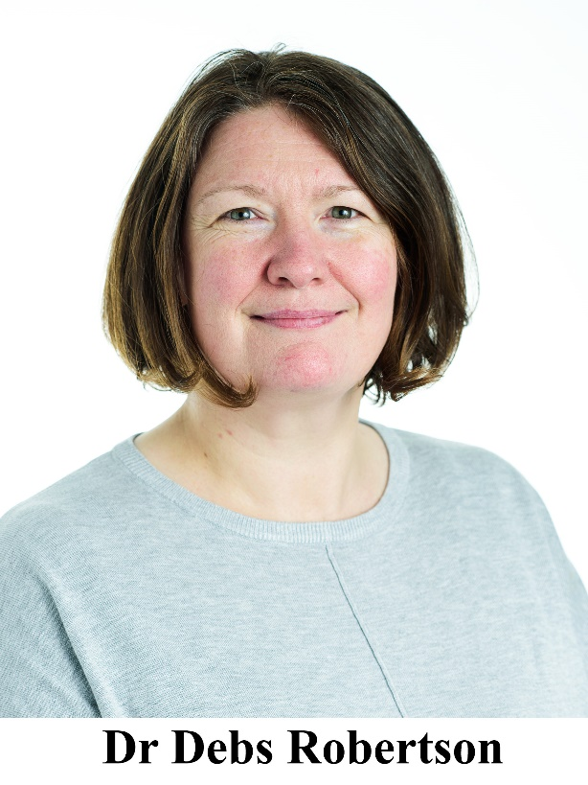
Dr Deborah Robertson joined the School of Health and Society at the University of Salford, Manchester in March 2018 to teach across pre and post registration programmes. Before this she worked in the faculty of Health and Social Care at University of Chester since 2004, to help teach NMP, as a Senior Lecturer in the Department of Public Health and Wellbeing. Deborah would describe herself as an RGN first and foremost but she also holds a BSc (Hons) and a PhD in Pharmacology. She worked for 3 years as a postdoctoral research fellow in the Department of Psychiatry at the University of Dundee and published her work in the area of stress and depression.
She has been teaching on the Non-Medical Prescribing Course for more than 15 years and her teaching areas on the programme focus on her areas of expertise, namely Pharmacology, Legal Aspects of Prescribing and Public Health. She has been part of the North West Collaborative of Higher Education Institutions in NMP since 2004 and has been involved in the development and continued provision of e-learning resources for NMP education. Deborah holds a postgraduate diploma in professional education and her current pedagogical interests involve e-learning and the delivery of the Non-Medical Prescribing Course.
Deborah is co-author, with Paul Barber, of a popular textbook, Essentials of Pharmacology for Nurses in its 4th edition, published by McGraw- Hill. She has also published her first solo textbook Essentials of Medicines Management in Mental Health Nursing.
For the past 7 years Deborah has been consultant editor for the journal of Prescribing Practice (previously Nurse Prescribing) a role which is challenging but one she thoroughly enjoys.

