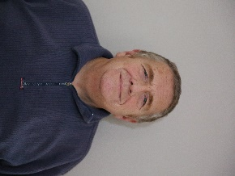

Gilbert Wheeler
Biography

Hello,
I like to be known as Gil.
Born in Southampton 1958, I have been an NHS patient for 63 years and this has seen me visit many hospitals across the country to receive treatment for my own health problems or needs
Since My diagnosis of a heart condition way back in 1990 I have been involved with patient engagement, patient support groups and patient participation roles both at local and national levels learning to both listen and speak up for the patient. Throughout my time with this involvement I have learned and helped to educate not only other patients but clinical staff as well. I now sit on health service steering groups looking at best practices, data, and funding for new ideas to supporting the cardiovascular patient now and in the future.

Thank you
Gil. Wheeler, Secretary of Cardiovascular Care Partnership, patient arm of British Cardiovascular Society.
glw958@gmail.com

