Michael Preston-Shoot

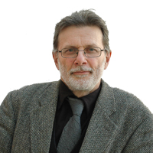
Michael Preston-Shoot is Professor Emeritus of Social Work at the University of Bedfordshire and a Fellow of the Academy of Social Sciences. His publications, research and training have concentrated on law and social work practice, adult safeguarding and effective practice with adults who self-neglect. He is currently Independent Chair of Lewisham and of Brent Safeguarding Adults Boards and Joint Coordinator of the National Network of Safeguarding Adult Board Chairs. He has authored safeguarding adult reviews, researched reviews of self-neglect cases, completed two regional thematic analyses of safeguarding adult reviews and carried out a sector-led improvement project on adult safeguarding and homelessness. In 2020, together with Suzy Braye and Research in Practice he completed the first national analysis of learning from safeguarding adult reviews across England.

