Mr Gabriel Sayer Associate Medical Director BHRUT NHS Trust

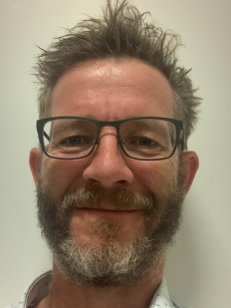

I have worked as a Consultant and Vascular Surgeon at BHRUT NHS Trust for 12 years. I have worked variously in roles of education and senior medical management as well as sustaining my clinical practice as an emergency and elective general and vascular surgeon. I have engaged with and developed Quality and Safety processes within my organisation at all levels. As the lead for Learning from Mortality I have tried to bring my passion for learning and teaching and my experience in quality improvement and management to engage with our multidisciplinary workforce. We have used the mortality review process to deliver improved models of care through engagement with the BHRUT Learning from Deaths strategy.