H@N Summit
Thursday 7th October 2021
Improving quality and safety for acutely deteriorating patients- our journey
By Claire Rowley

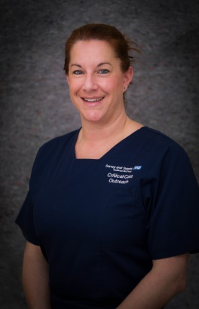
Biography- Claire Rowley (RGN)
I am the nurse consultant for the Critical Care Outreach Team at East Surrey hospital, a role I have been in since 2014. East Surrey Hospital is part of Surrey and Sussex NHS Trust which was awarded ‘Outstanding’ on its last CQC inspection. I have 27 years’ experience of working as a Critical Care nurse, and have seen a phenomenal number of changes during that time.
I am passionate about the prompt recognition and treatment of the acutely deteriorating patient, as well as end of life care. I am a ‘Q’ member through the Academic Health Science Network and love networking with like-minded healthcare professionals. I really enjoy teaching and am an ALS instructor, and am currently undertaking an MSc in Senior Leadership.
Outside of work I love swimming and being a mum to two children and one dog!

Abstract:
The role of the Critical Care Outreach team allows a non-blinkered view of the issues related to patient safety. The Outreach team cover the whole hospital, responding to emergencies as well as being asked for advice, making them the eyes and ears of the hospital. By using audit and experience to continuously improve the way we work and the way we do things, ensures that we provide the safest care we can. However, we are all human, and when things go wrong it is vital we learn from them to ensure they don’t happen again.
Over the last 6 years East Surrey Hospital has seen a marked increase in Medical Emergency Team calls and decrease in in-hospital cardiac arrest calls. This evidences improvement in recognising acute patient deterioration earlier, but puts pressure on the emergency response team who attend these calls. We know from audit that the majority of emergency calls are ‘out of hours’, so how do we ensure quality and safety for the patients? Initiatives such as the Emergency Call Safety Huddle; the Bedside Emergency Response Trolley (B.E.R.T); the Escalation of Treatment form to aid decision making; and the Medical Emergency Team documentation form are all part of our journey to improve quality and safety for acutely deteriorating patients. During this talk, the speaker will share how these initiatives came about and what impact they have had on both the patients and the staff.

--------------------------------------------------------------------------------------------------------------------------

