Professor Sandy Jack
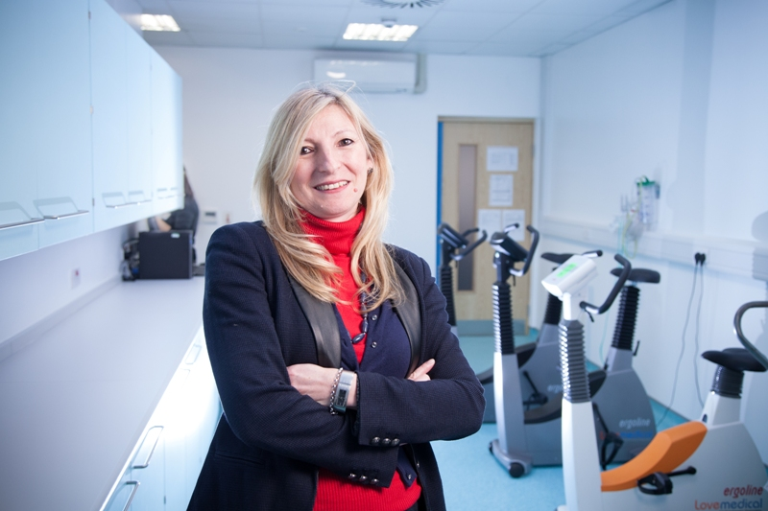Sandy is Professor of Prehabilitation Medicine in Clinical and Experimental Sciences Dept., Faculty of Medicine, at the University of Southampton. She is also Consultant Clinician Scientist in the Anaesthesia/Critical Care and Perioperative Medicine Research Unit, University Hospital Southampton NHS Foundation Trust. She is Co-Director of Fit-4-Consortium and Director of Centre for Human Integrative Physiology in the NIHR Research Facility. She has >20 years of experience in leading and delivering healthcare services across the public sectors, including community settings across the UK.

Sandy was an investigator on the Xtreme-Everest-2 expedition and lead investigator on the “Stress of Sailing Study” for the Volvo Ocean Race Team. She has> 13 years experience in prehabilitation medicine and is faculty on CPX European Practicum and UCLA Symposium on Clinical Exercise Testing and Interpretation. She is a Board member of the International Prehabilitation Society and the Perioperative Exercise Testing and Training Society. She was a key player in the development of the UK Macmillan/RCoA/NIHR Prehabilitation Guidance and also she is on the Personalised Care Programme Board for NHSE&I on behalf of Wessex Cancer Alliance.

She is a CI on a number of clinical trials, including the NHSE&I Sustainability and Transformation Partnership Cancer Transformation funded multi-centre Wessex Fit-Cancer Surgery Trial-WesFit (http://www.wesfit.org.uk), which is evaluating multimodal prehabilitation in patients undergoing major intra-cavity cancer surgery in the community settings. In response to the pandemic she transformed WesFit into SafeFit (http://www.SafeFit.nhs.uk) by utilising virtual clinics to deliver virtual multimodal interventions. This trial (badged as COVID-19 priority trial by NIHR Clinical Research Network) has secured £1.8M funding.

