Dr Peter Gough

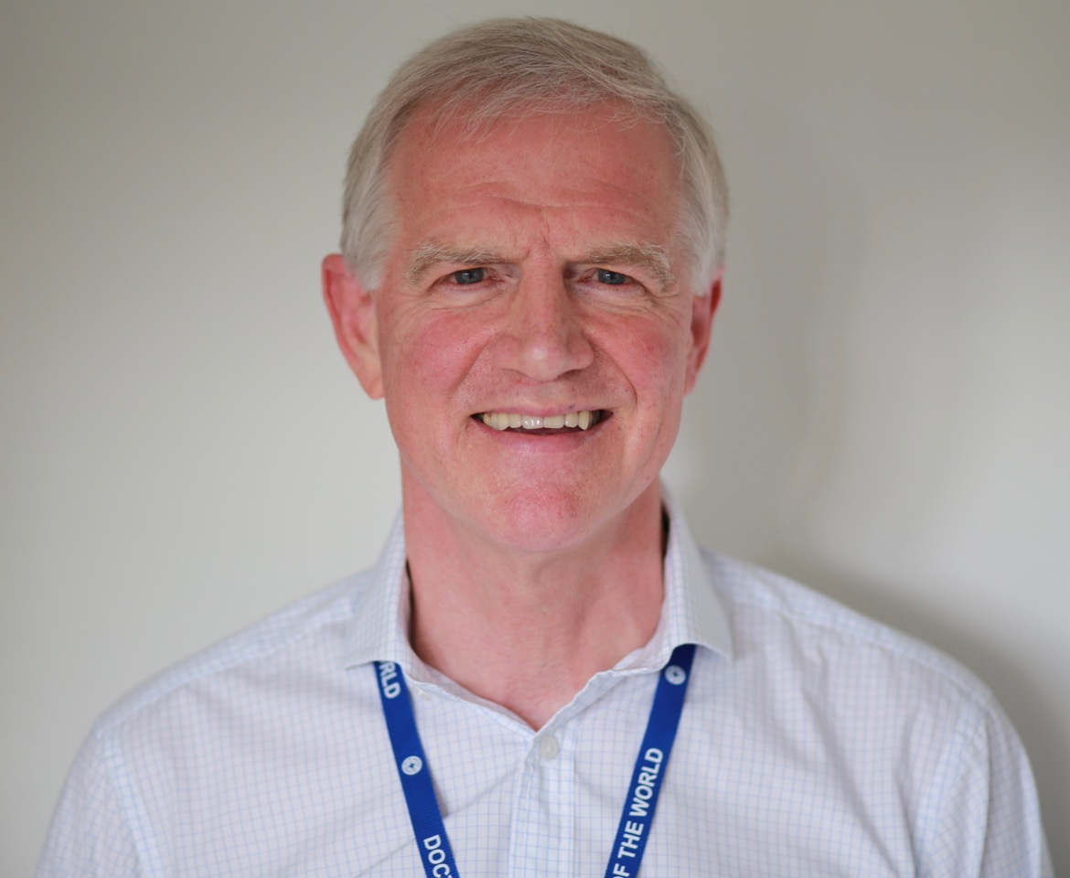

Peter is a GP Volunteer and Trustee of Doctors of the World, UK. He has been an NHS Doctor for 42 years and a Family Doctor for 37 years (30 years as a partner).

For the past 21 years, Peter has been involved with communities in Rajasthan, India addressing issues of migration, health, education, and the lack of opportunities for girls and women through the charity Khandel light which he co-founded with some of his patients. It is a community-to-community partnership of sharing responsibilities and skills. Convinced that such partnerships create lasting change for the health and wellbeing of all involved, he was privileged to be a founding Trustee of Addenbrooke’s Abroad, now Cambridge Global Health Partnerships.

Six years ago, Peter joined Doctors of the World UK, (part of the Médecins du Monde network) as a volunteer GP and has regularly worked in their clinics in East London, serving excluded people including asylum seekers, undocumented migrants, homeless people, and sex workers. Many of the people seen in these clinics have suffered from psychological and physical trauma, even torture. To enable him to improve his skills in dealing with these challenges, he took sabbatical leave from NHS practice in 2017 to study Psychotherapy and Counselling which validated what is, perhaps, a clinician’s most important skill, listening.

