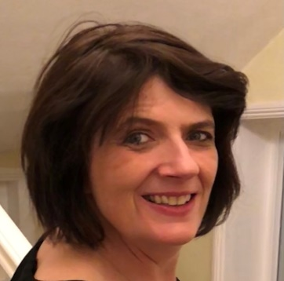
Sarah Thompson
Lead Haematology Advanced Nurse Practitioner
The Royal Marsden NHS Foundation Trust
I qualified as a nurse in 1990. I obtained my BSc in Adult Cancer Nursing in 2003 and my MSc in Advanced Practice in 2019. I am credentialled through the RCN as an Advanced Nurse Practitioner. Since 1992 I have worked mainly within the field of Haematology Nursing, working on inpatient units as well as on a medical day care unit. I became a Clinical Nurse Specialist for Haematology in a District General Hospital in 2000 and, whilst in post qualified as a Nurse Independent Prescriber in 2010. This was in response to the NPSA Safety Alert for Oral Chemotherapy in 2008, to allow me to set up a Pharmacy/Nurse led clinic for patients with Myeloproliferative neoplasms. In 2015 I became an Advanced Nurse Practitioner in a large inpatient Haematology Unit in London before moving to The Royal Marsden in 2017. In addition to my current management responsibilities, leading a team of Advanced Nurse Practitioners and Clinical Nurse Specialists, I work clinically across inpatient, outpatient, day case and clinical assessment units.
I am a committed teacher and my interests lie in developing nurse led services and extending clinical skills.
Sarah.thompson13@nhs.net

