Giles Birchley: Biography, Picture and Abstract
Biography:
Giles Birchley is a research fellow at the University of Bristol’s Centre for Ethics in Medicine. Giles has been working in academic bioethics since undertaking his PhD in 2012, following a previous career as a children’s intensive care nurse. He is currently a co-investigator on the Wellcome Trust funded “BABEL” project, which investigates how the concept of ‘best interests’ is used and understood across the life course in clinical practice, bioethics and the law. He was a trustee of the UK Clinical Ethics Network from 2018-2021, and is a member of the Bristol Acute Trusts Clinical Ethics Advisory Group and the Royal College of Paediatrics and Child Health’s Ethics and Law Advisory Committee.

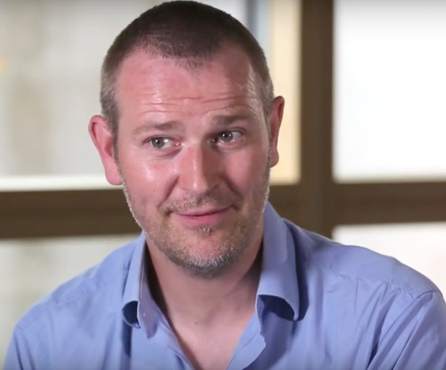

Abstract: Ethical decision-making: principles and practice
This talk will introduce you to the topic of ethics, explaining key ethical terms and concepts that inform medical ethics, and ending with a discussion of the ways ethics can support practice through clinical ethics support services. I will begin by focusing on ethics in theory, discussing what ethics can, and cannot, do, while considering why ethics have such a prominent place in todays healthcare environment. I will then consider what it means to have ethical expertise, before discussing three key ethical theories – based on rules (deontology), consequences (utilitarianism) and character (virtue ethics) through the ideas and examples of their seminal philosophers. I will then move on to a more practical focus, considering the ways ethical theories have informed the development of ethical principles and frameworks for practice, the way we should respond to conflict between ethical principles and the sorts of contributions clinical ethics support services can make to working through ethical challenges and building a better institutional environment.

