Dr Andrea Hilton
BPharm (Hons), MSc, PhD, PGCERT, SFHEA, MRPharmS
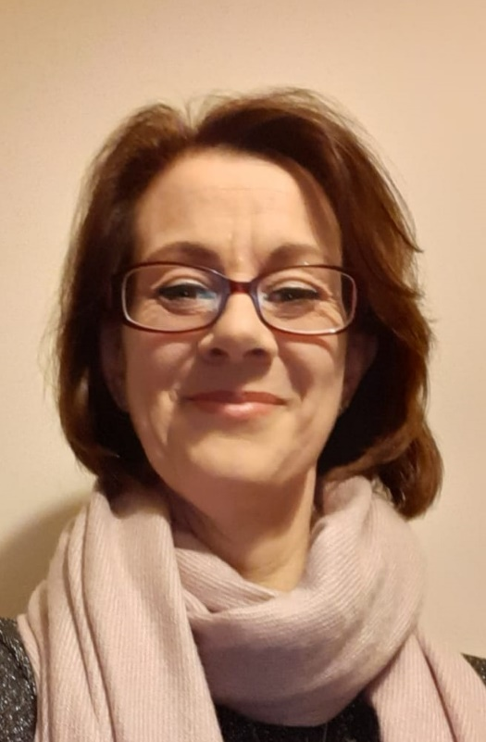

Andrea is a pharmacist who has previously worked in primary care and in community pharmacy, she is now a Reader and non-medical prescribing programme director at the University of Hull.
She gained her undergraduate degree (first class honours) in pharmacy from the University of Bradford in 1999, before completing an MSc in clinical pharmacy while working in secondary care.
Andrea completed her PhD in 2006 while working on the MRC-funded RESPECT trial. Her PhD was titled Development and Validation of a UK Medication Appropriateness Index.
Andrea has been involved with non-medical prescribing at the University since 2006, she has extensive experience of professional and statutory regulatory body (PSRB) accreditation/validation requirements for non-medical prescribing.

Abstract
Non-Medical Prescribing in Mental Health: Current Developments
This 30-minute session with questions will discuss several key aspects for prescribers and aspiring prescribers particularly around confidence and competence and conclude with a case study discussion on a scenario of a qualified non-medical prescriber expanding their role.
Andrea will start with an overview of competence and reviewing the competency framework for all prescribers⁽¹⁾. She will highlight the changes to the framework (2021) particularly around competency 8 and 9. She will discuss developments in non-medical prescribing in recent times and focus on remote prescribing and consultations⁽²⁾. She will link principles of remote prescribing and consultation to non-medical prescribing polices. Andrea will explore strategies for maintaining and demonstrating competency in non-medical prescribing. Delegates will then discuss a case study which Andrea will facilitate looking at some of the issues from the presentation. This will be complimented, and be explored further, in the next extended interactive session.
References:
- A Competency Framework for all Prescribers (2021). Royal Pharmaceutical Society. Available from: https://www.rpharms.com/Portals/0/RPS%20document%20library/Open%20access/Prescribing%20Competency%20Framework/RPS%20Competency%20Framework.pdf?ver=AlHRKuior3ef_fNnaMd3iA%3d%3d

- High level principles for good practice in remote consultations and prescribing (2019). Available from:
https://www.hcpc-uk.org/news-and-events/news/2019/new-principles-for-those-prescribing-remotely/
https://www.nmc.org.uk/globalassets/sitedocuments/other-publications/high-level-principles-for-remote-prescribing-.pdf

