Kirsty Fishburn 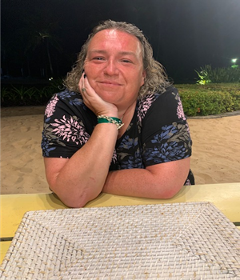
BSc (hons), INP, MSc, RMN, SFHEA, PhD Student
I became a mental health nurse when I realised I couldn’t be in the A-Team. Therefore, I have been and loved being a mental health nurse since 2000 and during that time I have worked mainly in secure forensic hospitals run by private providers. I have undertaken many courses course from CBT to Mentorship, then onto Management and Prescribing. I completed my MSc in 2011, in Health Professional Education. I have been a PhD student since 2016, exploring women’s lived experiences of Borderline Personality Disorder.
My clinical practice career took me from staff nurse to hospital director, then in January 2015 I left practice to go into the world of academia. I was always on a course at one university or another, so I decided to just go work there.... I feel honoured to have taken a post at the University of Hull. Also, being new to the world of academia and research I am very lucky to have been published quite a few times, in mental health prescribing and personality disorder…. Exciting times.
I am the programme Director for the mental health BSc at the university. We work very well as a team and looking at how we can best equip the student nurses with the skills they will need to become excellent qualified mental health nurses.
I qualified as a non-medical prescriber in 2007 and was an active prescriber in clinical practice, I found it a challenging and rewarding role, as I think it is very difficult to understand the accountability and responsibility we have in our role unless you actually can and do write a prescription. How we as prescribers maintain our confidence and competence, with the ever changing world of prescribing.
When I left practice I was asked to take on the module leader for the nurse’s independent and supplementary prescribing course at the university, a course of which I am very proud to be part of. This is a very exciting role with developing course content, assessments and linking in with other HEI’s, service providers and servicer users to develop robust courses and keeping them relevant and reflective of current prescribing practice.
An ever-developing world in mental health, that keep most of us excited and apprehensive at the best of times, but it is my passion.
When I have free time, I like to relax with my husband and a scary horror movie or go out to the movies and have fun time with the kids. My husband is a Wine Consultant and I drink beer… story of my life!
Thank you and I look forward to meeting you all.
Kirsty

