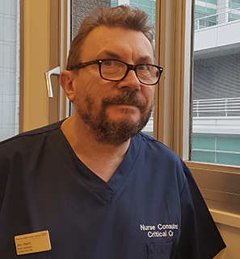
John Welch Biography
John’s been a Consultant Nurse in Critical Care & Critical Care Outreach for twenty years, currently at University College London Hospitals. He is UK lead of the European Union Horizon 2020 ‘Nightingale’ programme to develop wireless, wearable patient monitoring systems (www.nightingale-h2020.eu), immediate Past President of the international Society for Rapid Response Systems; and was the first Chair of the UK National Outreach Forum.
John is sepsis lead at UCLH, and was Clinical Lead - for Deterioration, then Sepsis - of the UCL Partners Patient Safety Collaborative which enabled significant reductions in cardiac arrests and mortality across the region with continuous measurement, analysis of human factors, and quality improvement. He was part of the National Early Warning Score Development & Implementation Group, and now sits on NHS England / NHS Improvement groups developing new Enhanced Care Areas, and the use of Clinician, Patient and Family Worry and Concern as methods to improve recognition of deterioration.
During the first COVID-19 pandemic, John was nurse lead of the set-up-from-scratch UCLH High Respiratory Dependency Unit, expanding critical care into general ward areas – avoiding the need for full ventilation in many cases - and also successfully treating significant numbers of patients with very poor prognosis.
Email John.Welch@nhs.net

