Philippe EGGIMANN MD  Senior physician, Senior lecturer  Department of Critical Care Medicine,  Lausanne University Hospital (CHUV), Switzerland  Philippe.eggiman@chuv.ch  Philippe.eggimann@fmh.ch | 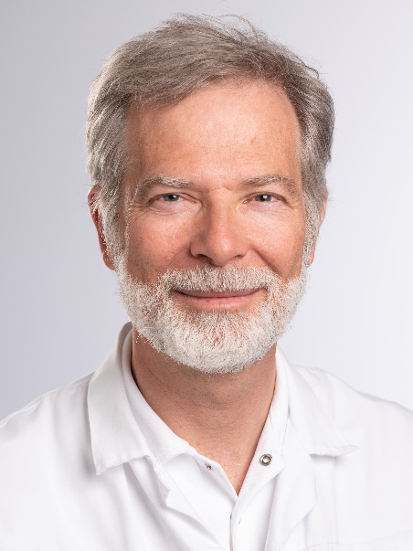
Short biography
Board certified in internal medicine, in infectious diseases and in intensive care medicine, Dr Eggimann has an established extended clinical and academic experience in tertiary referral centers (Geneva and Lausanne, Switzerland). He developed over the past two decades a sustained experience in the continuous improvement of the quality of care in critically ill patients. Dr Eggimann research fields include invasive candidiasis, micro-organisms targeted immunotherapy and the prevention of catheter-related infections. He acts as consultant to several scientific committees and is regularly invited as a speaker at international meetings on critical care and infectious diseases. He published 120 peer reviewed papers with an H-index of 35. Active in medical politics, he has been elected to the central committee of the Swiss Medical Association (www.FMH.ch).

