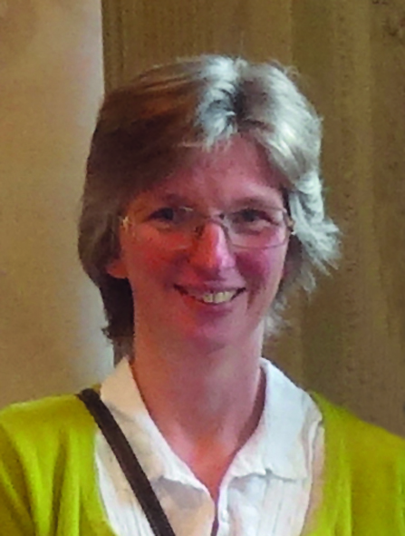Dr Mary Stocker
Past President, BADS
Torbay and South Devon NHS Foundation Trust
Mary read chemistry at Oxford University, including research into novel approaches towards drug design, subsequently she worked as a research chemist in the pharmaceutical industry. In 1990 she turned her hand to medicine, qualifying from Bristol University, her anaesthetic training was undertaken in the South West with a year at the University of Virginia, USA. She now works in Torbay as a Consultant Anaesthetist where she was Director of Day Surgery for over 15 years (2004-2020). Torbay is one of the national leading trusts for day surgery in terms of innovation, day case rates and the quality of patient outcomes. She has developed training modules in day surgery for medical students and anaesthetic trainees and a training course for nurses undertaking day surgery preoperative assessment. She worked with the Royal College of Anaesthetists to produce an e-learning package in pharmacology and more recently day surgery training packages. She has published widely in the day surgery literature and authored a number of book chapters on the subject.
She is clinical lead for day surgery and restoration of elective surgery for the Devon STP and is the day surgery advisor to various streams of the GIRFT Programme.
Mary has been a member of the council of the British Association of Day Surgery for 10 years, their conference secretary for 3 and President from 2016-2019.

