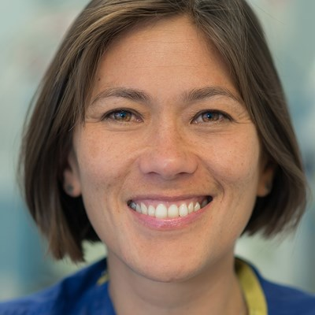Dr Kim Russon
Immediate Past President, BADS
The Rotherham NHS Foundation Trust
I am a Consultant Anaesthetist and Clinical Lead for Day Surgery at The Rotherham NHS Foundation Trust. I am privileged to have a fantastic Day Surgery team who are committed to delivering a high quality Day Surgery service and developing new day case pathways. We have many surgeons who promote day case and so we have managed to continue day surgery during the Covid-19 pandemic, including day case partial knee replacements, despite no inpatient Orthopaedic beds. In 2021 we have successfully started to perform day case total knee replacements and total hip replacements through our DSU. Our elective orthopaedic service has been ranked 11th nationally based on activity July 2021 compared to July 2019.
I also have an interest in Regional Anaesthesia (RA) and Education. I regularly teach on national RA courses and the RA MSC run by University of East Anglia. I was co-editor for the RA section of Anaesthesia Tutorial of the Week for 10 years. I have written RA articles, chapters in books and an E-Learning module. I was on the Society for Education in Anaesthesia’s council for 8 years (Secretary 2012-2015).
I have been on Council for the British Association of Day Surgery (BADS) since 2016 and organised the BADS Conferences in 2018 and 2019 and a number of BADS/HCUK speciality focused conferences. I am passionate about helping progress day surgery nationally and have given many presentations and have co-authored a number of BADS booklets and the BADS/CPOC/GIRFT National Day Surgery Delivery pack.
I took over as President of BADS in 2019 am pleased to report the Society has developed and grown and we now have over 600 members.

