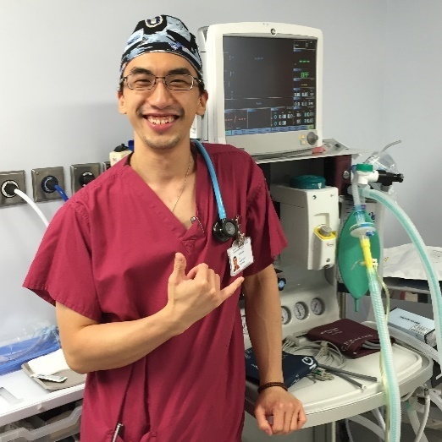
Dr. Justin Kua
MBBS, BSc (Hons), FRCA

I am a clinical research fellow for the Health Services Research Centre at the National Institute of Academic Anaesthesia, based at the Royal College of Anaesthetists. This posting is part of an ‘Out of programme for research’ fellowship which I commenced in August 2019. Towards the end of my first year, I opted to extend my fellowship to pursue a PhD at University College London under the supervision of Prof. Ramani Moonesinghe. My research is focused on investigating the impact of COVID-19 on healthcare and perioperative outcomes.

As part of my research fellowship, I also work as an intensive care fellow at The London Clinic, a private hospital based in Central London. I work alongside a remarkably talented and caring multidisciplinary team comprising intensivists, nurses, physiotherapists and other allied healthcare professionals. During the pandemic, we supported the NHS by absorbing a range of surgical cases, including cancer, renal, and vascular surgery. Prior to my fellowship, I was an anaesthetic specialist registrar training in the South East (London) School of Anaesthesia. My anaesthetic interests include obstetric and regional anaesthesia, and difficult airway management.

In my spare time, I have a strong passion for indoor rock climbing and specialise in a unique field known as ‘board climbing’.

