Ruth May
Short biography
______________________________________________________________________________________________________

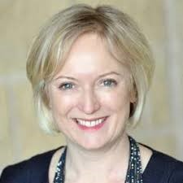
Ruth May
Chief Nursing Officer for England

Ruth took up the post of Chief Nursing Officer for England in January 2019, and before this enjoyed national appointments with NHS Improvement and Monitor as well as regional and Trust leadership roles. She is the national COVID-19 response lead for the nursing, midwifery and care professions in England.

As Chief Nursing Officer for England, Ruth’s priorities are to develop a workforce that is fit for the future, to renew the reputation of the nursing profession and ensure a collective voice that is powerful and heard.

Ruth is passionate about nurturing the next generation of NHS nursing and midwifery leaders, encouraging professional development opportunities and putting in place the optimal cultural conditions for all NHS employees to thrive. This includes advocating for improved mental health awareness, championing volunteer activity to support the frontline workforce and she is a vocal supporter of the WRES agenda and increased diversity across the NHS.

Proud mum to her young daughter, Ruth strives to balance her professional and home life, and encourages others to do the same.

Find Ruth on twitter @CNOEngland / #teamCNO

