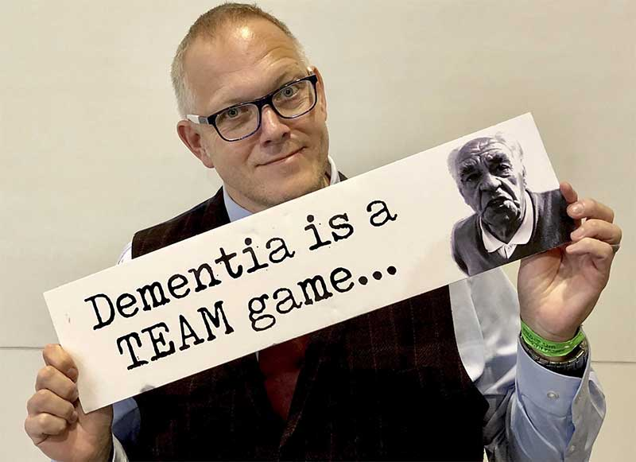
IAN DONAGHY
When you need a passionate keynote speaker who will inspire people and empower them to make a difference, look no further than Big Ian Donaghy.
Big Ian is more than a speaker, he is also a doer. He works tirelessly to raise dementia awareness and combat loneliness, always focusing on the individual drawing on his experience of 20 years teaching young people with learning difficulties, and nearly 10 years in the world of care.
Experienced in addressing and hosting conferences across the UK and Europe, Big Ian speaks with an infectious enthusiasm that is simultaneously entertaining and thought-provoking making audiences laugh and cry in equal measure.
Whether playing to 4000 or 40 Big Ian plays to audiences of one.

www.bigian.co.uk
https://twitter.com/trainingcarers

