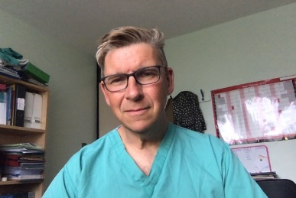Dr Matthew Checketts

Consultant Anaesthesiologist, Ninewells Hospital and Medical School, Dundee

I have been a consultant anaesthetist at NHS Tayside since 1998 and I work at both Perth Royal Infirmary and Ninewells Hospital and Medical School in Dundee. My clinical interests include day case paediatric surgery, trauma and orthopaedics and fast track/enhanced recovery techniques.

In 2019 I was granted a 3 month clinical sabbatical which allowed me to visit 10 hospitals in the UK, US and Denmark which was a great source of inspiration as well as personally and professionally refreshing - I recommend others to explore this option.

I introduced SipTilSend in NHS Tayside which abolishes pre-operative fluid deprivation for all patients - both unplanned and planned surgery. Our media fluid fasting times have fallen from 6 h to 17 minutes! SipTilSend is becoming a worldwide phenomenon and is being adopted in multiple other centers. You will hear more during my presentation.

During the Covid lockdown, I started a weekly online eclectic music radio show called Heavens's Mixtape on Mixcloud that has become my essential creative outlet - give it a try - [Mixcloud.com/HeavensMixtape.](http://mixcloud.com/HeavensMixtape)