Prof Jeremy C Wyatt MB BS, DM, FRCP; Fellow of American College of Medical Informatics & UK Faculty of Clinical Informatics

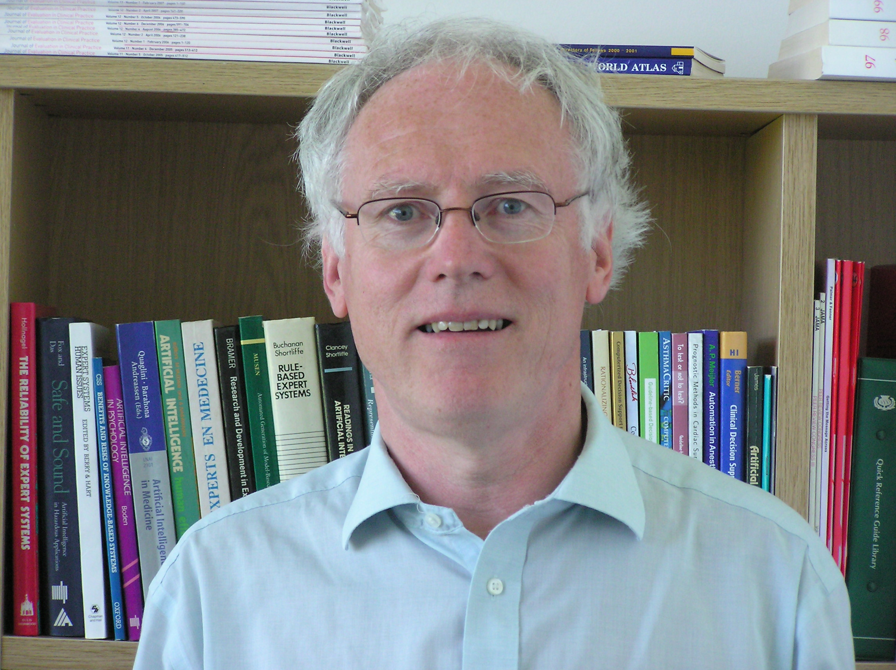
LinkedIn: uk.linkedin.com/pub/jeremy-wyatt/14/236/2ab/
ResearchGate: https://www.researchgate.net/profile/Jeremy_Wyatt2
Google Scholar: https://scholar.google.com/citations?user=HeRqPJoAAAAJ&hl=en
ORCID ID 0000-0001-7008-1473
Email: j.c.wyatt@soton.ac.uk
Skype: jcwyatt42

Jeremy is Emeritus Professor of Digital Healthcare and former Director of Wessex Institute and Clinical Adviser on New Technologies to Royal College of Physicians. He currently leads the FCI’s Special Interest Group on AI, convenes UK activity on Mobilising Computable Biomedical Knowledge (MCBK) and is a member of Medicines & Healthcare Regulatory Authority’s Devices Expert Advisory Committee. He was previously Leadership Chair in eHealth Research in Leeds, setting up the £7M MRC Biomedical Informatics Centre in Leeds Institute of Data Analytics. His research uses empirical methods to uncover scientific principles guiding the design of clinical information and eHealth systems, studying interactive tools to change the behaviour of clinicians (eg. decision support), patients (eg. apps, telehealth) and the public (eg. SMS msgs to promote healthy lifestyle), and of digital tools to support health research.

Jeremy trained in medicine in Oxford and London and as a hospital physician there & Glasgow (MRCP 1983). He then discovered medical informatics and health technology assessment with doctoral training at the National Heart & Lung Institute and an MRC-funded postdoc at Stanford. He was the UK’s first elected Fellow of the American College of Medical Informatics in 1997, was ranked third in his discipline worldwide in 2009 and has given 40 invited overseas talks in the last decade, including the Amsterdam Spinoza lecture series.

In his spare time he makes jewellery and commemorative objects in titanium:
https://www.marlboroughopenstudios.co.uk/exhibiting-artists/jeremy-wyatt

Main achievements
Jeremy set up NICE’s R&D programme 2003-5, the Dundee Health Informatics & eHealth Centre 2005-10 (precursor to Scotland’s Farr node) and the Warwick Institute for Digital Healthcare in 2010. He was member of WHO’s mHealth Technical Advisory Group 2010-12 and developed and taught a WHO course in Tehran. He is visiting professor in Oxford, Amsterdam and Oporto universities and wrote the agenda for and minuted the June 1992 McMaster meeting which, with Brian Haynes & Iain Chalmers, established the Cochrane Collaboration. He also set up Cochrane’s Effective Practice & Organisation of Care review group in 1994. He has written three textbooks on evaluation methods and digital / eHealth, five series of tutorial articles for medical journals and over 200 articles with an H index of 58. He is a Founding Fellow of the Faculty of Clinical Informatics and the International Academy of Health Sciences Informatics.

