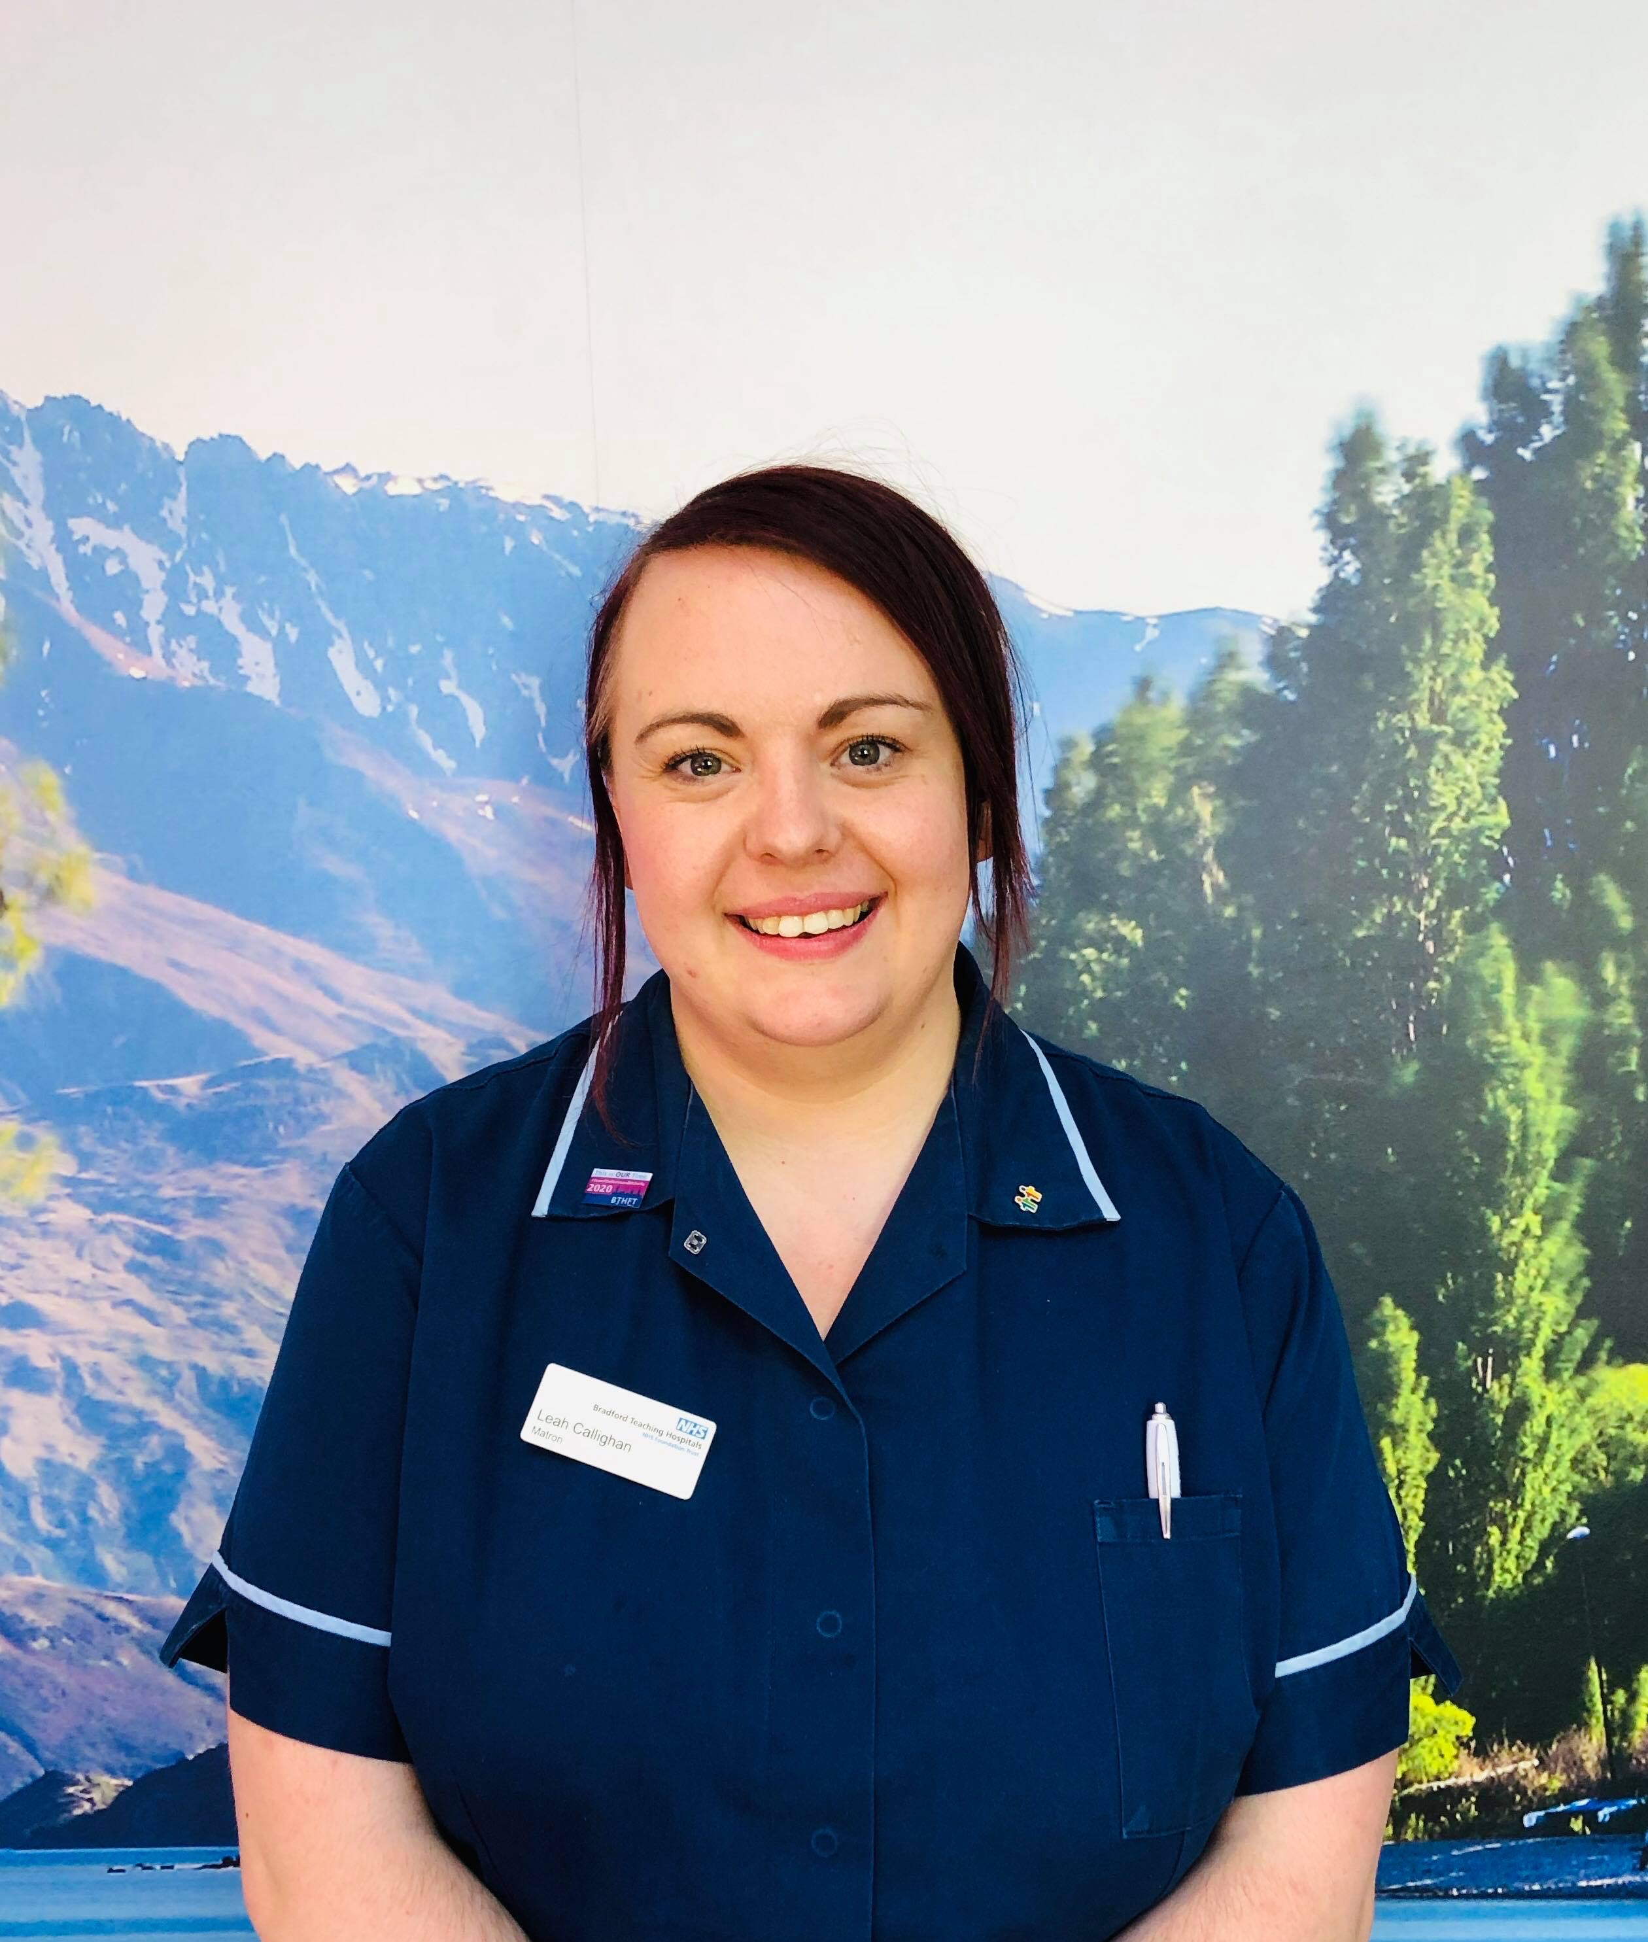
Abstract
Hello everybody – my name is Leah Callighan and I am a Matron at Bradford Teaching Hospitals NHS Foundation Trust. Sometimes I still have to pinch myself I am in this role, as I feel incredibly privileged to work with my colleagues to help create happy working environments and ensure patients are receiving safe care and treatment.
I am Bradford born and bred – it is a great place to live and work! At BTHFT, we pride ourselves on kindness which makes such a difference. I joined the Trust aged 17 as an Apprentice Receptionist in the Education Department. I completed my NVQ’s in Business Studies and Customer Service as I saw myself running my own business one day. As time went on, I thought it was strange working in a hospital and I had never actually seen a patient before…. So I decided to do a ‘trial’ bank shift as a Health Care Assistant. Wow! Loved it, there and then I knew this was the job for me!
I pursued my Nursing Qualification and proudly qualified as a Registered Nurse in September 2013 with an Advanced Diploma of Higher Education in Adult Nursing. I shortly after found myself in a Junior Sisters position, this is where I realised it is leadership I adore. I moved across specialities ranging from Infectious Diseases to Orthopaedic Trauma, meaning I was constantly learning and expanding my professional network.
I became a Ward Manager in 2017, again moving across specialities from ENT to Short Stay Medial Unit. I developed my leadership skills and qualities and found myself in a position where I could really influence change, I soon moved from been a leader to embracing compassionate leadership.
Aged 29 in 2019, a Matron post was advertised…. Why not I asked? I don’t have a chance of been successful I told myself, but it is good interview experience and an opportunity to showcase my achievements. I absolutely was beyond proud when I was appointed! In 12 years I had gone from Apprentice Receptionists to Matron!
I have learned a lot on my journey which has taken me from a shy teenager to a professional woman! My presentation will talk about the highs and lows of the role, how to happy staff will deliver exemplar care and the importance of taking care of ourselves.
Particularly over the last year, I have felt such admiration for ward and department leaders. Unimaginable pressures from activity, flow and service delivery all whilst trying to keep your team motivated, safe and assured. But who looks after you? What do you do to keep your physical and mental health a priority? Get thinking and I look forward to hearing about these!

