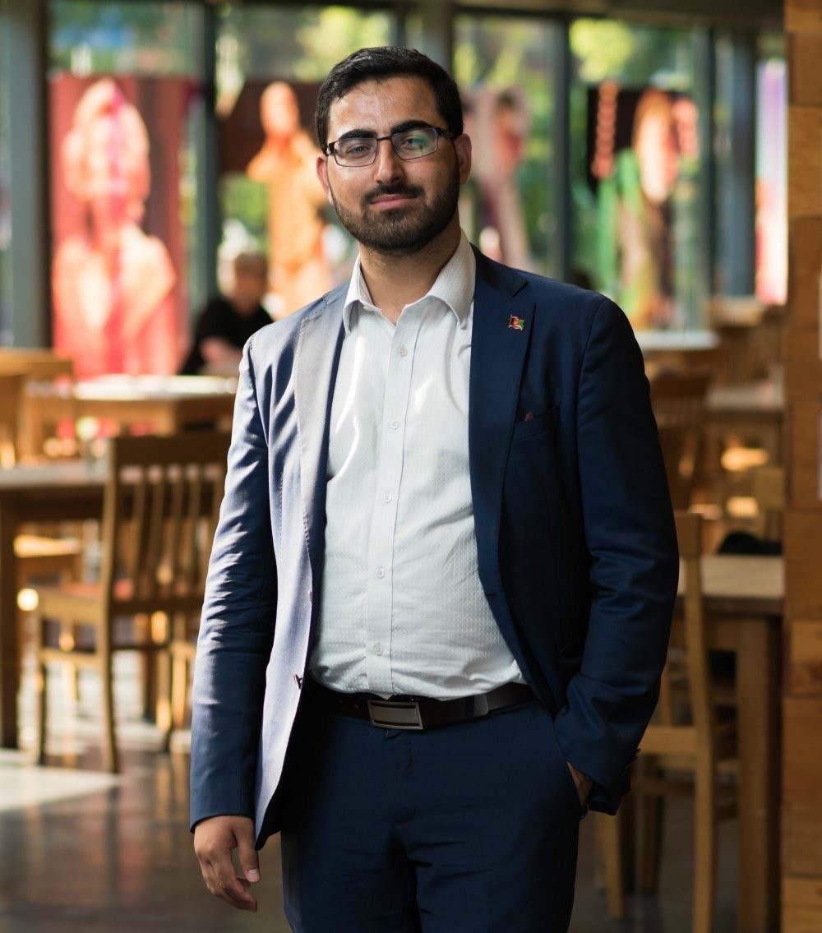Gulwali Passarlay
Author, The Lightless Sky, Activist, and
Consultant, Passarlay Limited

Gulwali is a dedicated advocate and spokesperson for refugees and asylum seekers across the U.K and is the Co‐Founder of not‐for‐profit organisation “My Bright Kite CIC”.

Since arriving in the UK in 2007 after being forced to leave Afghanistan as a 12 year old boy, Gulwali has achieved beyond all odds to become a well‐respected and sought after public speaker, influencer and political campaigner for refugee’s rights, social justice and education. The experience of his journey to the UK shaped his future and inspired an insatiable determination and commitment to raise awareness and make a difference for other refugees.

Among his many achievements, Gulwali graduated with a Politics degree from The University of Manchester and he has recently finished his MPA at Coventry university. Gulwali is the esteemed author of his best selling autobiography, "The Lightless Sky: A Twelve‐Year‐Old Refugee's Harrowing Escape from Afghanistan and His Extraordinary Journey Across Half The World".

In his talks, Gulwali shares his captivating story of struggle, danger and resilience and how he miraculously survived the harrowing year long journey from Afghanistan to the UK, on his own, after being separated from his brother. Through his talks, audience’s young and old, are able to achieve an understanding of the extent of adversity that refugees face and thus be inspired to instigate positive change in their environments.

